Slide 1:
Joliet Junior College
Department of Adult Education and Literacy
Orientation and Enrollment
Slide 2:
Welcome to the Department of Adult Education and Literacy.
Our department offers four types of classes.
High School Equivalency, known as HSE, is a program designed for students who are working towards completing the GED or HiSET exam in language arts, social studies, math, and science.
English as a Second Language, known as ESL, which is a program for students who are learning or improving their English language skills in reading, writing, speaking, and listening.
Citizenship classes are offered to those who are preparing for their citizenship interview.
Workforce Ready Classes: These classes are offered to all students and will focus on HSE or ESL content plus technology skills such email and Microsoft products such as Word and Excel.
*All links in this presentation are available in the description below.

Slide 3:
Registration Process
There are 4 steps to registration. NOT completing one of the four steps will stop the registration process.
Step 1. Orientation PowerPoint, which you are currently viewing.
Step 2: Complete the enrollment form.
Step 3: Testing. Schedule an in-person or remote placement test.
Step 4: Placement in class. Check your email for class confirmation.

Slide 4:
Class Options
Class schedules to meet your needs!
- 16, 12, and 8-week classes available
In-person Classes
- Morning or evening
- City Center (downtown Joliet) or Romeoville campuses
Hybrid Classes
- Morning or evening
- City Center (downtown Joliet) or Romeoville campuses
Online Classes
- Morning or evening

Slide 5:
In-person: How it Works
Face to face: A traditional class where the student will come to one of our campuses two days a week for class.
Attendance: 40+hours class time is required; homework may be expected.

Slide 6:
Hybrid Classes: How it Works
- In-person - Attend class once a week on campus.
- Remote - Attend class via Zoom. Participation is required.
- Attendance – 40+hours of in-person class plus Zoom learning is required.

Slide 7:
Online Classes: How it Works
Zoom: You are required to participate in two weekly Zoom sessions a week. You choose a morning or evening schedule to meet your needs.
Computer Time: Additional time will be spent in your assigned software.
^{HSE: Essential Education}
^{ESL: Burlington English}
Phones can be used to complete assignments.
Attendance: 40+hours of Zoom class time is required.

Slide 8:
^{Be Prepared!}
When you arrive for testing, please be ready to tell your proctor your class preferences.
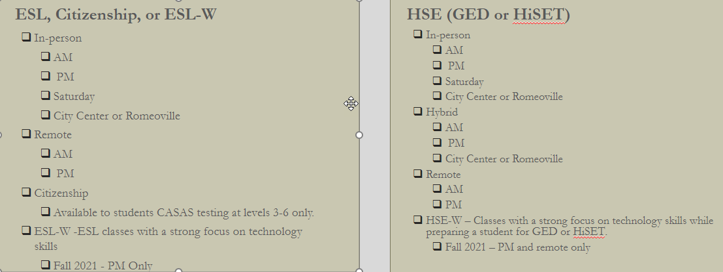
Class options may be limited to availability at time registration is completed.
Slide 9:
ESL
Students in our English as a Second Language (ESL) classes will be using Burlington English for their assigned software.
Burlington English combines grammar, listening, speaking, reading, and writing into their program.

Slide 10:
HSE
TABE Academy is used for students wishing to achieve their High School Equivalency and TABE testing at levels 1-3. In this program, a student will build foundational skills in reading and math.

GED or HiSET Academy is for students wishing to achieve their High School Equivalency and TABE testing at level 4. In this program, a student will work on developing skills in reading, social studies, math, and science that are required for the GED and HiSET exams.

Slide 11:
HSE- i-Pathways
i-Pathways is the software required by the Illinois Community College Board for all students TABE testing at levels 5 or 6 and working towards completing their High School Equivalency. In this program, a student will work on polishing up skills in reading, social studies, math, and science that are required for the GED and HiSET exams.
Slide 12:
Resources
Your success is important to us!
All resources listed here are FREE.
- Tutoring through the Department of Adult Education and Literacy (DAEL): Extra help with any subject English as a Second Language, reading/writing, math, science, or social studies.
  - gkhartul@jjc.edu
- Tutoring through JJC: For levels 4-6. Meet regularly with a tutor or as needed.
  - Tutoring@jjc.edu
- Technology or additional needed student support.
  - Ckramer@jjc.edu
- Transition Advising: Completed your HSE or ESL? Get help with your next steps.
  - mlyman@jjc.edu
- Disability Services: If you require accommodations, contact their office as soon as you register.
  - disabilityservices@jjc.edu

Slide 13:
FERPA: Family Educational Right to Privacy Act
A student requiring staff and/or a teacher to discuss school information with a parent, guardian, or others will need to complete the online FERPA agreement found at JJC.edu under FERPA Information and Forms.

Slide 14:
Step 2: Enrollment Form
After completing this video, move to Step 2 by completing the enrollment form.
Please, DO NOT complete more than one enrollment form.
Questions? Call 815-280-1333

Slide 15:
Contact Information on Enrollment Form
Enrollment form: Make sure to share an email you check regularly as that is how we will contact you about classes.
Check your email for information on:
  - Class assignment
  - Teacher contact information
  - JJC Student ID#
*If your Family is part of the Plainfield School District or Valley View School District, mark your school district on your Enrollment Form

Slide 16:
Step 3: Testing
Once you have completed your enrollment form, you will need to sign up for a placement test.
  - It is VERY important that you complete the placement test. If you do not, we cannot place you in a class.
  - Please carefully select a time for testing that you know will work for you. DO NOT sign up for more than one test session.
    - Questions? Call 815-280-1333.
Slide 17:
Step 4: Placement in Class
If Steps 1-3 have been completed, you will receive an email a week before classes begin with your teacher(s) name, email, and your JJC ID#.
Please be sure to check your Inbox and Junk/Spam folder for an email from DAELStaff@jjc.edu.

Slide 18:
Technology Preparation
Remote and in-person workshops will be offered to prepare you for the coming semester.
- JJC email set-up
- Software assignment
  - Sign-in
  - Basics of the program
Look for an email and/or text for sign-up options.

Slide 19:
Follow Us!
The Department of Adult Education and Literacy can be found on the following at JJCDAEL:
- Facebook
- Instagram
- YouTube
- Twitter
Keep up to date on department happenings.

Slide 19
Questions?
If you have additional questions, please contact our office.
Email: DAELStaff@jjc.edu
Phone: 815-280-1333

Slide 20:
Welcome to the JJC Community!

